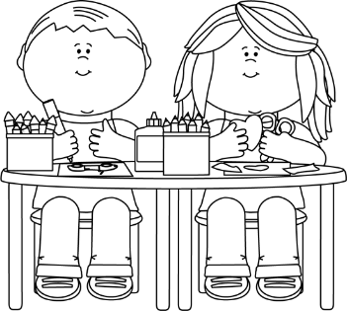

Ms. Suzy’s Class 1-01

~ October 16-20 ~

**What We’re Learning**

**Reading**

Essential Question: What jobs need to be done in a community?

Comprehension Focus: Determine the main topic of a text,

**Word Work**

Students will learn to read and spell words with short /e/. Students will also learn the inflectional ending -ed.

**Spelling Words**

1. leg
2. beg
3. men
4. hen
5. head
6. bread
7. there
8. again

**High Frequency Words**

1. again
2. help
3. new
4. there
5. use

**Student of the Week**

Ace Myers

**Important Dates**

**October 20-** Unit 2 Wk 1 test; spelling test

|  |  |  |  |  |
| --- | --- | --- | --- | --- |
| **Monday** | **Tuesday** | **Wednesday** | **Thursday** | **Friday** |
| Worksheet | Worksheet | Worksheet | Study for Spelling test | None |

**Homework**

**Notes from the Teacher**

Email:   
Ascuittose@scsk12.org  
School number:901-416-4495  
Cellphone:  
504-908-5644

* **Study spelling each night**
* Students need **headphones** daily for I-ready Instruction
* Read 15 minutes daily with students
* If your student misses a day of school, please send a note
* Sign up to volunteer at School-O-ween

